**National Trends:**

**Primary Sector:**

In the 1900’s the biggest sector was the Primary sector, many people owned farms and big patches of land to grow crops and livestock, these where then sold to the secondary sector at allot of profit. This is because people did not import much back then so you had to source everything locally, so farmer’s crops and livestock where in high demand. Nowadays this has declined as we import for overseas where they have optimum temperatures and climates to specialise in growing certain crops for a higher yield with better quality.

**Secondary Sector:**

In the 1900’s the secondary sector was busy because we did not import, so we had to make everything from what was cultivated from the primary sector. Nowadays the secondary sector is decreasing because we need less labourers, this is because we have one machine to do the job of twenty men, only needing one man to control the machine. Any work we employ people to do we usually employ overseas as they have less safety regulations, are paid a lot less and work longer hours. Some businesses such as Ford have removed all or most of their factories in England to employ overseas for a cheaper price.

**Tertiary Sector:**

In the 1900’s the tertiary sector was mainly based on market stalls and small sole trader owned shops, they sold the fish that where fished in be the fishermen. Nowadays the tertiary sector is the most popular sector with most people working in it. We will always need people to teach the next generations, to care for us and to sell us the products made in the other sectors. It has seen and increases because people are leaving the primary and secondary sectors for easier jobs with less physical labour and the ability to just sit at a desk all day.

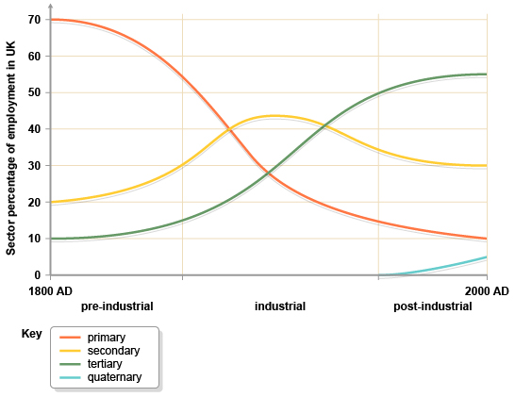 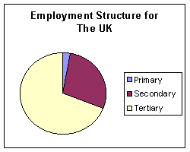

**Local Trends:**

**Primary sector:**

In the 1900’s the biggest sector for Great Yarmouth was the fishing sector, Before the first world war, it ranked as the premier herring port, and each year large catches were brought into Great Yarmouth. After WW2 however, there was a steady decline as new methods and machinery was introduced. Nowadays we rely on overseas importation for most of our fish as it is cheaper as the regulations are not as strict and we get a wider variety of fish which are cheaper.

In the 1900’s we relied on coal and gas to power our homes which came from mining, now we have an increase in this sector as we have installed 30 wind turbines just off of the coast, meaning we create our own power, which is bring clean and renewable energy to Great Yarmouth. This has supplied the local area with many jobs to fix and maintain these turbines and an increase in this sector. This is because society has seen an increase in the importance of going green, using renewable energy to save the planet.

**Secondary Sector**

In 1900’s the secondary sector was very popular because all of the raw materials that where extracted from the primary sector are sent to the secondary sector to be made into finalised products. This is because nothing was imported to overseas as it cost a lot of money to pay for importation fees. Nowadays the secondary sector has declined as everything is imported overseas for cheaper production costs.

**Tertiary Sector:**

There has been a decline in tourism in the local area due to the rise in industrial estate in great Yarmouth meaning most of the holiday parks are not as busy and the gift shops are slowly closing down because no one wants to buy gifts as no one is visiting the area. So we rely on the other parts of the sector.